Jun
29
2018
Avila sewer
Northern Chumash Object to Proposed Avila Development
https://northernchumash.org/2018/06/29/avila-sewer/

People protect what they love.
In its latest meeting, the Avila Advisory Council (AVAC) heard a proposal from Somera Capital Management, TG Gamble concerning 50 cottage-style rentals and a lodge to be constructed overlooking San Luis Bay Drive on the property adjacent to the Avila Beach Resort Golf Course. The presentation was an effort to keep the community informed on the project and seek public input.

Northern Chumash Tribal Council member, Violet Sage Cavanaugh
Along with the concerns addressed by the council around water allocation and traffic impact to the community, Northern Chumash Tribal Council member, Violet Sage Cavanaugh, informed the gathering that the construction site sits on an important landmark to the Chumash people. Born and currently living in Avila, Cavanaugh displayed her displeasure on the project in no uncertain terms.

“I want everybody in this room to really think about what we’re seeing here, it’s the most important site to the Chumash people in all of the northern territory in all of San Luis Obispo,” said Cavanaugh. “We don’t take it lightly.”

Cavanaugh explained the dirt road leading to the lodge and cottages, that the project required expansion on, passes directly over an ancient burial site and the necessary construction of a sewer line would also pass through her people’s final resting area.
“The road going in and out of the property is a huge problem, going over our sacred site and our burial site here,” said Cavanaugh. “That’s where we stand, that’s where all the northern Chumash people stand.” She also displayed her disgust with the proposed placement of the sewer line. “It made me sick to see a sewer line running through a cemetery.”
Somera did not respond to the public comment. Principal for Somera, David Brown was not available for comment days after the AVAC meeting but relayed the message that once the application is formerly in, they would be able to discuss the project. The County issued a hold letter to the company requesting more information before the application can be processed. Following the process of the application, the company would perform an Environmental Impact Study (EIR).
In a phone interview, Cavanaugh said that generally, the indigenous people do not speak of sacred sites to the public, however, given the severity of the situation she felt obligated to inform the public the importance of the area and what it means to the tribe.
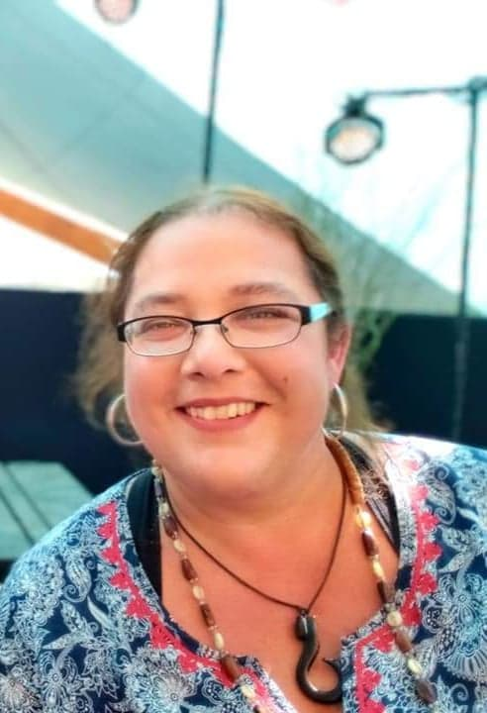
According to a New Project Referral submitted to the County of San Luis Obispo Department of Building and Planning in April 2018, the company was made aware by the Northern Chumash of the “sensitive archaeological resources” and development “would not be welcome.” The report also states, “…the applicants will work with the County and Northern Chumash to select appropriate mitigations and will engage an archaeologist and Native American to monitor all earth disturbance within sensitive cultural areas.”
An estimated 10,000 Chumash lived on the Central Coast in 1770, however, due to exposure to disease, enslavement and California government sponsored systematic eradication in the form of bounties, the population in 1910 dropped to only 74.

