The National Park Service Centennial and the California Central Coast
Why not a Pecho Coast National Seashore?
By John Ashbaugh
This year, the National Park Service is celebrating its Centennial at all of its 412 units, covering 84 million acres of spectacular landscapes, beaches, deserts, forests and waters.
I, like most Americans, are utterly enthralled with our National Parks. As a child, I remember vividly our regular family outings to Lassen Volcanic National Park near our home in Redding. My family also car-camped in many of the western National Parks when I was a child, and my wife Patricia and I continued that tradition with our own family.
For me, the National Parks are a place of respite, inspiration, and connection to the complexities and magic of the natural world. They also serve to remind all Americans of our history, and the even longer “pre-history” of the many cultures and communities of Native Americans who once inhabited these lands.
I was reminded of this connection many times over this summer of the NPS Centennial – and it got me to thinking: Why don’t we have a National Park here in San Luis Obispo County? In my considered opinion, we SHOULD – and there’s a great candidate right in our own back yard. But let’s review what we have already here on the California Central Coast.
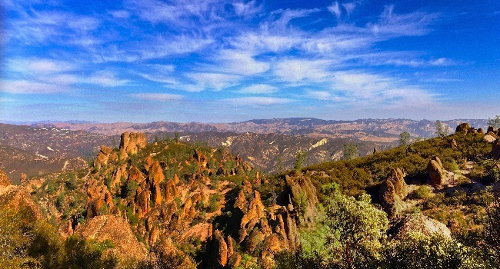
The nearest NPS unit to our home in San Luis Obispo, at 110 miles, is also one of the newest National Park units, Pinnacles National Park in southern Monterey County. It’s an extraordinary example of geological uplift in the Gabilan Range, best visited in the winter or spring; there’s a brand new visitor center there, and 25,000 acres of vertical stone torn asunder by the most powerful forces known to us - the San Andreas Fault.
Pinnacles National Park, Monterey County
The Carrizo Plains National Monument southwest of Shandon is technically a unit of the National Park system, and it is closer at only 71 miles – but it is administered by the Bureau of Land Management rather than the NPS. In many ways, this is a bureaucratic distinction without a real difference (although many local advocates for the Carrizo Plains would beg to differ).
An act of Congress is required to declare a National Park: For example, Pinnacles NP was enacted in 2013, through legislation introduced by Congressman Sam Farr, who retires at the end of this year. A National Monument like the Carrizo Plains requires only an executive order by the President under the Antiquities Act of 1906. President Bill Clinton signed the proclamation creating the Carrizo Plains National Monument on January 17, 2001, just three days before leaving office. Many National Parks were first protected as National Monuments by the President, e.g.: Teddy Roosevelt declared Pinnacles National Monument in 1908, the same year he designated Grand Canyon National Monument (later designated a National Park by Congress in 1919).
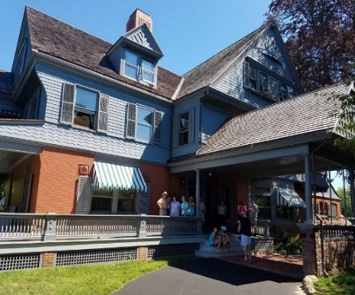
This year, our vacation in early August, 2016 was “bookended” by two units of the National Park system on the East Coast: Sagamore Hill National Historic Site in NY, and Acadia National Park in southeastern Maine.
Sagamore Hill National Monument, the 1885 Home of Theodore Roosevelt in Oyster Bay, NY
Sagamore Hill National Historic Site, Oyster Bay, NY
Sagamore Hill was the home of President Theodore Roosevelt, credited as our greatest conservation President. Today, visitors to Sagamore Hill experience the same close connection with nature that Roosevelt created in his own home in the beauty of rural Long Island and the adjacent waters.
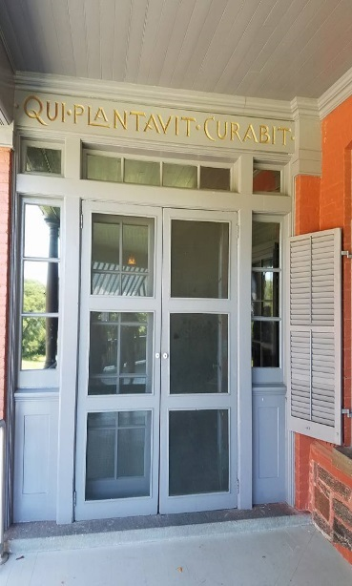
It’s possible to stand on Roosevelt’s front porch at Sagamore Hill and literally feel the effervescence of nature all around you. Roosevelt knew that we all share an intimate connection with the soil, with native flora and fauna, and with the systems that provide us with our food and fiber. Over the doors of his home is the Latin slogan, “Qui Plantavit Curabit” – He Who Plants, Preserves.”
Front Door at Sagamore Hill – “He Who Plants, Preserves.”
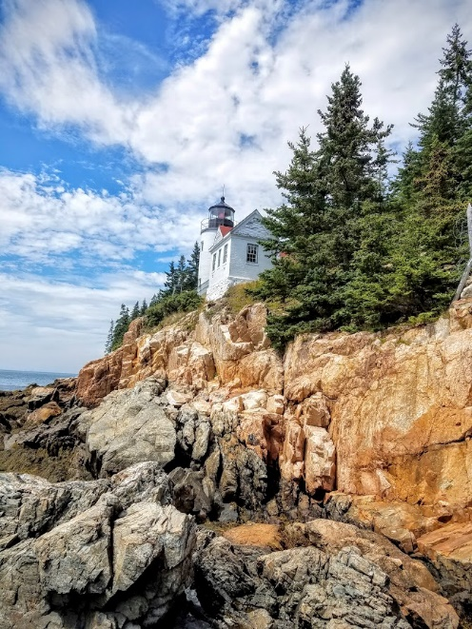
It was Sagamore Hill where Theodore Roosevelt entertained leaders from around the world, where he returned from his duties as President to recharge his soul, where he and his second wife Edith raised six children, and where he died in 1919. As our 26th President, Theodore Roosevelt protected more land than any other President and set the stage for the creation of the National Park Service in 1916.
Bass Harbor Lighthouse, Acadia National Park

Acadia National Park
Where Sagamore Hill represents the pastoral, cultivated farm where a great conservationist had made his home, Acadia National Park in Maine gave us sheer wildness in its windswept, rocky landscape of dense forests touched by the tides of history. Acadia National Park also celebrated its Centennial this year: President Woodrow Wilson proclaimed it as a National Monument in 1916, and it was the first National Park east of the Mississippi.
Theodore Roosevelt had spent a very formative summer at Schooner Head in Acadia in 1880, during which he courted the woman he would marry that fall (only to lose her less than four years later in childbirth).
Acadia National Park is 47,000 acres of graceful coastal forests and rocky headlands, with wetlands and ponds and wildflowers and mushrooms and hundreds of species of birds and mammals. The Park draws almost 3 million visitors a year to camp, hike its 120 miles of trails, or bicycle a 50-mile network of carriage trails built by John D. Rockefeller in the 1930s. Popular features include the Bass Harbor Lighthouse, Cadillac Mountain, and Jordan Pond. Our days were devoted to hiking and biking, as well as touring the Park on the excellent transit system that links the entire island to the main Visitor Center in Bar Harbor, a few blocks from our B&B.
Pecho Coast National Seashore – A Proposal
After these visits to two of our finest National Park units on the East Coast, my thoughts returned to the Central Coast, and to the prospects for a National Park in this area. We have a unique confluence of events that suggest an opportunity for the people of San Luis Obispo County to take advantage of recent events to advance a proposal for a new National Park unit that I’ll call – for the time being – the “Pecho Coast National Seashore.”
Last June, PG&E announced that the Diablo Canyon Nuclear Power Plant would begin the long process of “decommissioning” in 2025. This facility is the last operating nuclear power plant in California, and with its closure, our region will see a net economic loss of about $1 billion.
The County and nearby cities are reeling in the face of this announcement. Over the last three months, we’ve been urging PG&E to raise the $50 million fund that it has so far committed to mitigate the economic loss that will be felt in the nearby cities and school districts.
Even before the planned closure was announced, I had been urging SLO County leaders to engage in “post-Diablo” planning so that we can transition smoothly into a future without Diablo Canyon. The fact is that for over a half-century, our County has benefitted from the economic stimulus provided by PG&E here – but continuing Diablo Canyon as an operating nuclear power plan would require significant new investment, and PG&E has other priorities now: They’ve made a commitment to exceed the State’s requirement that 50% of its electrical power be derived from renewable, sustainable non-nuclear sources by 2030.
The plans for Diablo Canyon will require careful deliberation and intelligent leadership for at least the next decade. What is truly significant now, however, is the opportunity that presents itself due to the fact that this energy company has exercised such careful stewardship over the 12,800 acres of pristine coastal lands surrounding the Nuclear Power Plant.
Why not take advantage of that vast protected area and combine PG&E’s holdings with the 8,000-acre Montana de Oro State Park to it, to assemble a major coastal unit that qualifies as a unit of the National Park Service? Let’s think even bigger –why not add the 2,400 acres of Wild Cherry Canyon, as well as the historic 1892 Port San Luis Lighthouse, owned by the Port San Luis Harbor District, at its southern end? Together, we would have almost 25,000 acres of land that could easily qualify as a unit of our famed National Park system, right in our back yard!
What would it take to create such a magnificent park? The most important ingredient is the land itself – no problem there. Beyond that, we must demonstrate strong cooperation with all landowners (both public and private), enthusiastic support within the surrounding communities, and unified local political leadership.
A National Park would require an Act of Congress, as well as action by the State Legislature and the Parks and Recreation Commission. Support must be solicited, too, from nearby communities such as Morro Bay, Los Osos, San Luis Obispo, Avila Beach, and the “Five Cities” area.
The idea for a Pecho Coast National Seashore will be controversial, to be sure – but it is also very timely: Federal support would be enormously helpful in securing the funding needed to buy out the interests of PG&E and its partner in Wild Cherry Canyon, Homefed Corporation of San Diego. A few hundred acres in and around the power plant would need to be “carved out” of the Park boundaries for DCNPP decommissioning, and for the storage of spent fuel – at least until the Nuclear Regulatory Commission can find a suitable long-term repository for that hazardous material.
Local interest groups that are key to the “grassroots” support we will need include the Land Conservancy, Sierra Club, Audubon Society, Native Plants Society, Morro Bay Natural History Association, Surfrider Foundation, Whales Cave Conservancy, Friends of the Port San Luis Lighthouse, and the Friends of Wild Cherry Canyon. Historical and archaeological preservation advocates as well as local Chumash leaders will want to weigh in on how best to protect the many outstanding historic and pre-historic sites throughout this area.
Designating this 25,000 area as a National Park or Seashore would be perfectly compatible with the proposed Chumash National Marine Sanctuary that would stretch from Estero Bay south as far as Point Concepcion. That area, if accepted by the National Oceanic and Atmospheric Administration, would be administered by a separate agency, and would focus primarily on marine research and sustainable fisheries management.
We are very privileged in the Central Coast to have the opportunity to hold out to the nation, and to the world, an outstanding landform and seascape that offers so much, so close, to so many. The time is ripe to begin a conversation here, in Sacramento, and in Washington about what we can do together to create this unit of the National Park system right here in our own “backyard.”
John Ashbaugh is a member of the San Luis Obispo City Council, and was the founder of the Land Conservancy of San Luis Obispo in 1984. He is on the Social Science faculty of Allan Hancock College in Santa Maria.

